Source: <https://sparkfruit.ph/product/mh-et-live-hb100-x-10-525ghz-microwave-sensor/>

Description

Description:

MH-ET LIVE HB100 X 10.525GHz Microwave Sensor 2-16M Doppler Radar Human Body Induction Switch Module For ardunio

The microwave motion sensor is a microwave moving object detector designed using Doppler radar principle. Unlike ordinary infrared detectors, microwave sensors detect the motion of an object by detecting microwaves reflected from the object. The detection object will not be limited to the human body, and there are many other things. The microwave sensor is not affected by the ambient temperature, has a long detection range and high sensitivity, and is widely used in industrial, transportation and civil devices such as vehicle speed, automatic doors, sensor lights, and parking sensors.

Because of the universality of microwave sensor detection objects, in actual life applications, it will be matched with another sensor for targeted detection. Such as microwave sensor + infrared pyroelectric sensor, can effectively determine whether someone passed, will not be the sun, was disturbed by the color of clothing, will not respond to other objects.

characteristic

This detection method has the following advantages over other detection methods:

1. non-contact detection;

2. not affected by temperature, humidity, noise, airflow, dust, light, etc., suitable for harsh environments;

3. anti-radio frequency interference ability;

4.the output power is small, do not harm the body structure;

5. detection distance;

6. Support the detection of non-life objects

7. the direction of the microwave is very good, the speed is equal to the speed of light;

Product parameters

Working voltage : 5V±0.25V

Operating Current (CW): 50mA max., 30mA typical

size: R=30.6mm

Emission parameters:

 Detection distance: Used with adapter plate or reference circuit below, 2-16m continuously adjustable (minimum 2m, maximum 16m)

Helium emission frequency : 10.525 GHz

Frequency setting accuracy : 3MHz

Output power (minimum): 13dBm EIRP

harmonic emission: <-10dBm

Average current (5%DC) : 2mA typ.

Pulse width (Min.): 5uSec

Duty cycle (Min.): 1%

Receive parameters:

Sensitivity (10dB S/N ratio) 3Hz to 80Hz Bandwidth: -86dBm

10.3Hz to 80Hz Bandwidth Clutter 10uV

Antenna gain: 8dBi

Vertical 3dB beam width: 36 degrees

Water level 3dB Beam width: 72 degrees

Size Chart Pin Description

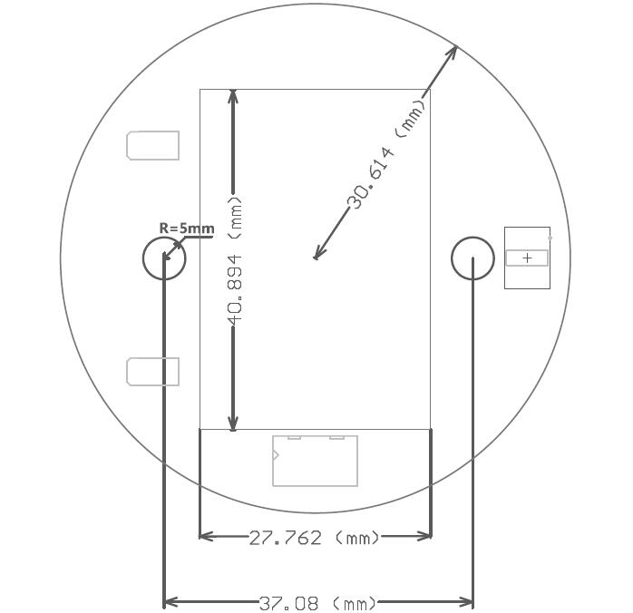

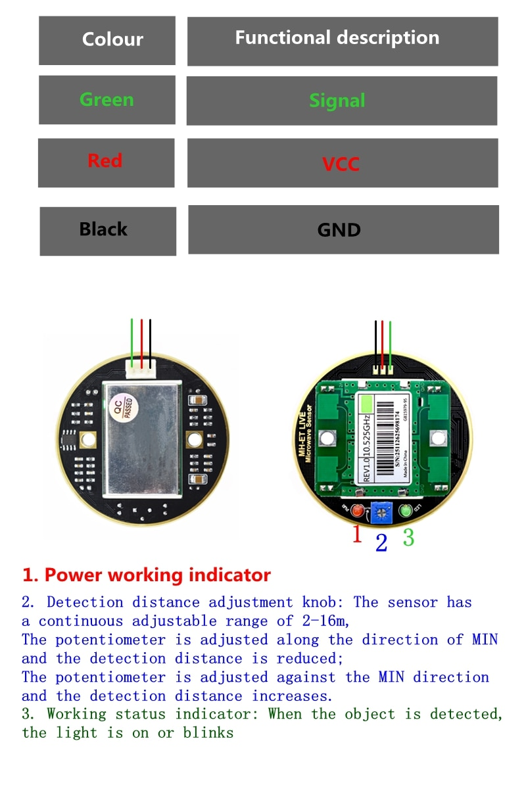

Use the tutorial

Wiring diagram:

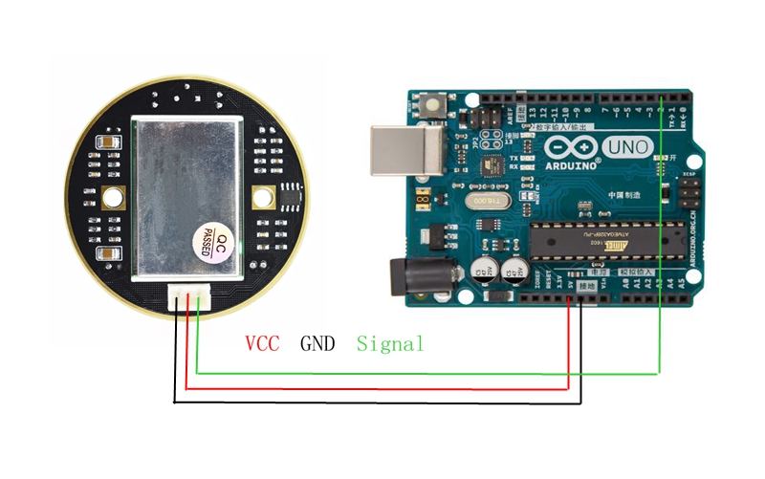

Routines:

#include <MsTimer2.h> //Timer interrupt function

Int pbIn = 0; // Define the interrupt PIN is 0, that is, digital pins 2

Int ledOut = 13;

Int count=0;

Volatile int state = LOW; //Define ledOut, default is off

Void setup()

{

     Serial.begin(9600);

     pinMode(ledOut, OUTPUT);

     attachInterrupt(pbIn, stateChange, FALLING); // Sets the interrupt function, falling edge triggered interrupts.

     MsTimer2::set(1000,process); // Set the timer interrupt time 1000ms

     MsTimer2::start();//Timer interrupt start

}

Void loop()

{

    Serial.println(count); // Printing times of 1000ms suspension

    Delay(1);

    If(state == HIGH) //When moving objects are detected later, 2s shut down automatically after the ledout light is convenient.

  {

    Delay(2000);

    State = LOW;

    digitalWrite(ledOut, state); //Turn off led

  }

 }

Void stateChange() //Interrupt function

{

  Count++;

}

Void process() //Timer handler

{

  If(count>1) //1000ms interrupt number greater than 1 is considereddetected a moving object (this value can be adjusted according to the actual situation, equivalent to adjust the detection threshold of the speed of a moving object)

       {

                   State = HIGH;

                   digitalWrite(ledOut, state); //Lighting led

                   Count=0; //Count zero

       }

        Else

            Count=0; //In 1000ms, interrupts does not reach set threshold value is considered not detect moving objects, interrupt the count number is cleared to zero.

}

Note: The sensor has a continuous adjustable range of 2-16m, the potentiometer is adjusted along the MIN direction, the detection distance is reduced; the potentiometer is adjusted against the MIN direction, and the detection distance increases.